|  |  |
| --- | --- |
| **TM1637** | |
| VCC | 5V – Breadboard |
| GND | GND – Breadboard |
| DIO | Digital 9 |
| CLK | Digital 8 |
| **Matrix Led Display 8x8** | |
| VCC | 5V – Breadboard |
| GND | GND – Breadboard |
| DIN | Digital12 |
| CS | Digital11 |
| CLK | Digital 10 |
| **LCD – I2C** | |
| GND | GND – Breadboard |
| VCC | 5V - Breadboard |
| SDA | Analog A4 |
| SCL | Analog A5 |
| **Buttons** | |
| Button1 | Digital 2 |
| Button2 | Digital 3 |
| Button3 | Digital 4 |
| Button4 | Digital 5 |
|  |  |
| **Breadboard** | |
| 5V - Breadboard | 5V – Arduino |
| GND - Breadboard | GND – Arduino |

**Buttons Triggering**

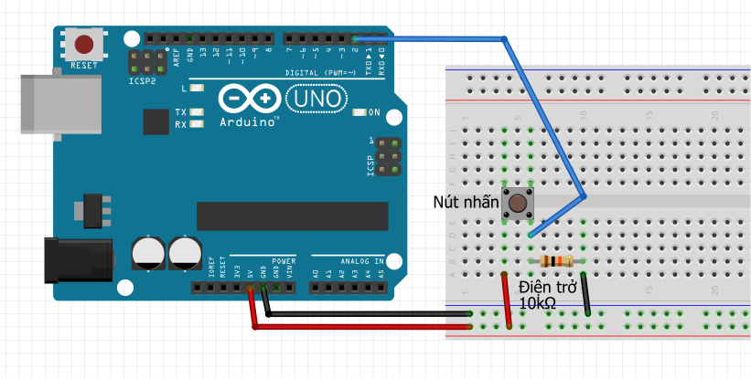

Giống hệt hình trên, cổng INPUT được nêu như ở phần ***Buttons*** ở table

Link sản phẩm:

TM1637:

<https://hshop.vn/products/grove-4-digit-display-hien-thi-4-led-7-doan>

Ma trận Led:

<https://hshop.vn/products/mach-hien-thi-led-ma-tran>

LCD + I2C + Buttons:

[https://www.facebook.com/jun.anh.2411](https://www.facebook.com/jun.anh.2411/)

Arduino & Breadboard:

Hàng CLB